BECA / Huson / 12.1. IB Math SL Name:

October 24, 2017

**Calculus limit question**

**1a.** Let  .

Expand  . *[2 marks]*

**1b.** Use the formula 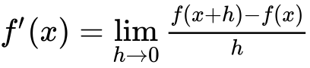 to show that the derivative of  is  . *[4 marks]*

**1c.** The tangent to the curve of *f* at the point  is parallel to the tangent at a point Q. Find the coordinates of Q. *[4 marks]*

**1d.** The graph of *f* is decreasing for  . Find the value of *p* and of *q*. *[3 marks]*

**1e.** Write down the range of values for the gradient of  . *[2 marks]*